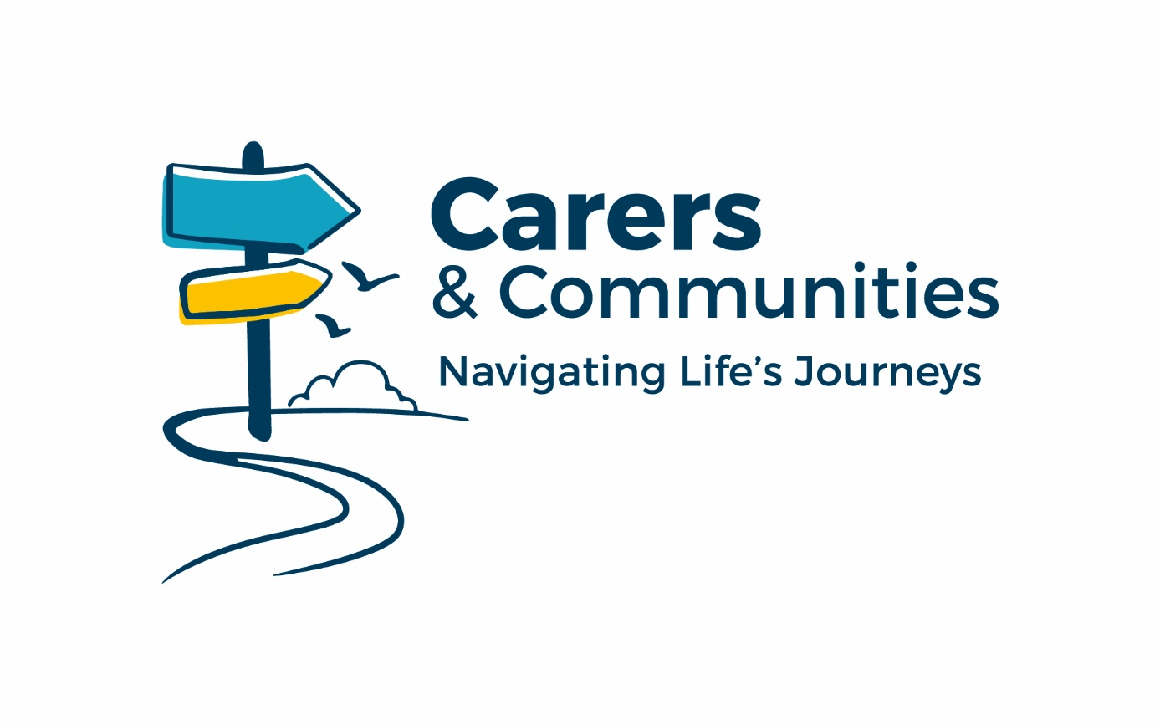

Application Pack
Community Mental Health Link Worker
September 2026

About Us
Carers & Communities (C&C) is a registered charity which was founded in 1997. We act as an independent source of information, advice and support for unpaid carers across the county.

Working for Us
At Carers & Communities, people are at the heart of everything we do. We are a dependable, caring and fair organisation where everyone is treated with respect, valued for their contribution and supported to do their best work.

Our teams are united by a shared purpose: making a meaningful difference to the lives of unpaid carers and the communities in which they live. We work collaboratively, encourage new ideas and focus on practical improvement so that our services remain responsive and effective.

When you join us, you will become part of a committed team that works together to create positive, lasting impact for unpaid carers.

About You
You will be a compassionate, motivated and person-centred individual who is passionate about improving the lives of carers who are either living with or caring for someone with an enduring mental health condition. You will have the ability to build trusted relationships with people from a wide range of backgrounds, recognising the unique experiences and pressures faced by carers and those living with enduring mental health conditions. You will enjoy working collaboratively as part of a busy team and be confident developing positive relationships with professionals and support services.



Community Mental Health Link Worker
Responsible to: Deputy CEO and Services Manager

Place of Work: Worcester Office (hybrid working by agreement)

Hours of Work: 22.5 hours per week, worked over 3 days, including a Monday

Contract Type: Permanent

Pay Scale: £25,972 per annum, pro rata for part time hours

Job Overview
You will be working as part of a professional team supporting carers on a 1:1 basis by enabling carers to access advice and information which will support them in their caring role. The Community Mental Health Link Workers engage with carers who look after someone who is living with an enduring Mental Health (MH) condition or carers who are diagnosed with a Mental Health condition themselves.

Key Objectives
- Enhance carers’ health and wellbeing by providing high-quality personalised information, advice and support – identifying the outcomes most important to carers and empowering them to make informed choices and build resilience.
- Equip carers to better meet the demands of their caring role using a person centred approach, tailored to the individual needs of the carer – this may include self-serve and digital options.
- Complete strengths-based needs assessments to identity areas impacting the carers own mental health as well as supporting them to understand the mental health condition of the cared for.
- Attend regular NHS multi-disciplinary team (MDT) meetings to identify carers who are caring for a patient supported by the Neighbourhood Health Teams across the county.
- Develop a good understanding of the mental health pathways and services as well as accurately using our internal client record management system.

Main Duties and Responsibilities

- Enhance carers’ health and wellbeing by providing high-quality personalised information, advice and support – identifying the outcomes most important to carers and empowering them to make informed choices and build resilience.
- Ensure the early identification of carers needs at MDT meetings and provide appropriate and effective advice, practical and emotional support.
- Undertake interventions to include: understanding mental health conditions, crisis planning, coping/resilience strategies and guided 1:1 self-help sessions.
- Develop an excellent knowledge of opportunities and resources available to carers in Worcestershire.
- Support the facilitation of carer events and practical information sessions, both online and in person.

2. Equip carers to better meet the demands of their caring role using a person-centred approach, tailored to the individual needs of the carer – this may include self-serve and digital options.
- Proactively promote and support carers digital confidence in accessing online services to include support with attending online sessions and utilising the Carers Online Platform for self-serve.
- Introducing and supporting Carers to access Carers and Communities eLearning resources.

3. Complete strengths-based needs assessments to identity areas impacting the carers own mental health as well as supporting them to understand the mental health condition of the cared for.
- Support carers on a 1:1 basis and manage a caseload of carers.
- Complete assessments to identify carer needs by telephone, virtual appointments and where appropriate face to face, adopting a strengths-based approach.
- Promote resilience by supporting with coping and resilience strategies.
- Support carers to develop crisis plans and provide support so carers can recognise symptoms and signs of when their cared for is approaching a crisis.
- Proactively encourage appropriate carer involvement in service development and monitoring.

4. Attend regular NHS multi-disciplinary team (MDT) meetings to identify carers who are caring for a patient supported by the Neighbourhood Health Teams across the county.
- Identify carers when attending MDT’s and request referrals.
- Work in partnership with MH professionals for the best possible outcomes for carers.
- Represent the organisation at NHS MDT and Neighbourhood Mental health team meetings to increase carer identification and referrals.

5. Develop a good understanding of the mental health pathways and services as well as accurately using our internal client record management system.
- Develop and maintain excellent partner relationships with the NHS and partner voluntary sector organisations to ensure the delivery of a joined-up and coherent provision for carers.
- Be efficient, responsible and maintain a high level of personal organisation; keeping timely, accurate and appropriate records and providing information for monitoring and evaluation as required.
- Work to all contractual key performance indicators.
- Contribute to service development and improvement through the identification of service gaps, opportunities and improved referral pathways and support transformation and innovation within Carers services.
- Provide support and supervision to students on placement. Undertake workplace supervisor training and participate in mandatory updates.
Support and supervise nominated volunteers or coordinate volunteer-led services

6. General Responsibilities
- Maintain professionalism, organisation, accountability and confidentiality.
- Work in line with organisational policies, including safeguarding, equality, diversity, data protection and health and safety.
- Participate in supervision, training, team meetings and organisational events as required.
- Use organisational resources responsibly and support efficient service delivery.
- Undertake training and development relevant to the role.
- Contribute positively to the wider Carers & Communities team and culture.

Person Specification

E=Essential D=Desirable
Experience | E | D
Working with individuals diagnosed with an enduring or severe mental health condition | x
Managing difficult conversations with clients and working with people over the phone, face to face and online. | x
Managing priorities and competing demands in a busy environment to meet deadlines | x
Working with IT systems such as Microsoft 365 and client data systems | x
Working to organisational policies and quality standards | x
Working with carers |  | x
Working with partners such as the NHS, voluntary sector and other statutory services |  | x
Knowledge
Understanding of issues affecting unpaid carers | x
Knowledge of mental health conditions, symptoms and presentation | x
Outcome orientated approaches | x

Awareness of health, social care and voluntary sector systems |  | x
Awareness of Care Act 2014 responsibilities relating to carers and the Mental Health Act 2007 |  | x
Skills
Clear communication, listening and relationship-building skills | X
Good organisational, planning and problem-solving abilities | x
Ability to accurately record data and feedback to support service improvement | x
Ability to prioritise workload and respond flexibly to day-to-day demands | x

Other Requirements
- Relevant posts will be subject to standard or enhanced DBS check.
- Ability to travel to and from our office location and to other outreach locations.
- Willing to undertake training and personal development.

Benefits
Occupational Pension, Employee Assistance Scheme, Wellbeing Support, Blue Light Card.

How to Apply:

Please forward your CV and a covering letter using the template provided. In this template you should provide a brief explanation of how your skills, knowledge and experience match each of the 5 areas of responsibility.

If you do not provide a CV or the cover letter, your application will not be considered, and you will not be invited for interview.

If you are invited for interview, we will also ask you to complete an Information Form asking for further information relating to your employment, references and other relevant checks.

Please send your CV and cover letter to: recruitment@carersandcommunities.org.uk as soon as possible. We will close to applications early if there is a high level of interest.

Interviews will take place on a rolling basis as suitable candidates are identified.

We are committed to safeguarding and promoting the welfare of children, young people, and vulnerable adults, and we expect all staff and volunteers to share this commitment.
All successful applicants will be required to undertake an enhanced DBS check (or equivalent) and provide references covering the last 5 years of employment. We follow safer recruitment practices in accordance with statutory guidance to ensure the people we appoint are suitable for the role.
Our recruitment process includes rigorous checks on identity, employment history, qualifications (where applicable), and the right to work in the UK. Any gaps in employment will be explored during the selection process.
We value diversity and welcome applications from all sections of the community. Appointments are made on merit, and we are committed to creating an inclusive environment where everyone can thrive.

