Role Description – Retail Volunteer

Become part of our wonderful boutique Charity Shop Team and support unpaid carers in our community.
Everyone cares for their families and friends. But some family members and friends need extra care and support due to illness, a disability or a condition. If you provide that care, you are a Carer.
Carers & Communities provides a range of services to help carers and the communities in which we live. Donating your time by helping in our Droitwich Shop enables us to identify more carers who need support.
General Retail Volunteer
We are looking for volunteers to help with general shop duties such as using the till, sorting donations, steaming clothes and helping customers.
No experience is necessary as full training will be given.
For further information or to apply for a volunteering role please contact:-

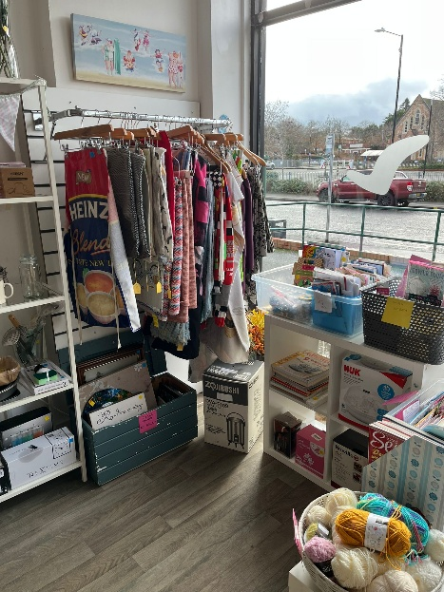
To volunteer with us you need to be aged 18 or over.
Suze Smith – Retail Lead
Email: ssmith@carersandcommunities.org.uk
Phone: 01905 770367 or 07785 619658
Visit Us: 53, Ombersley Street East, Droitwich Spa, WR9 8QS

