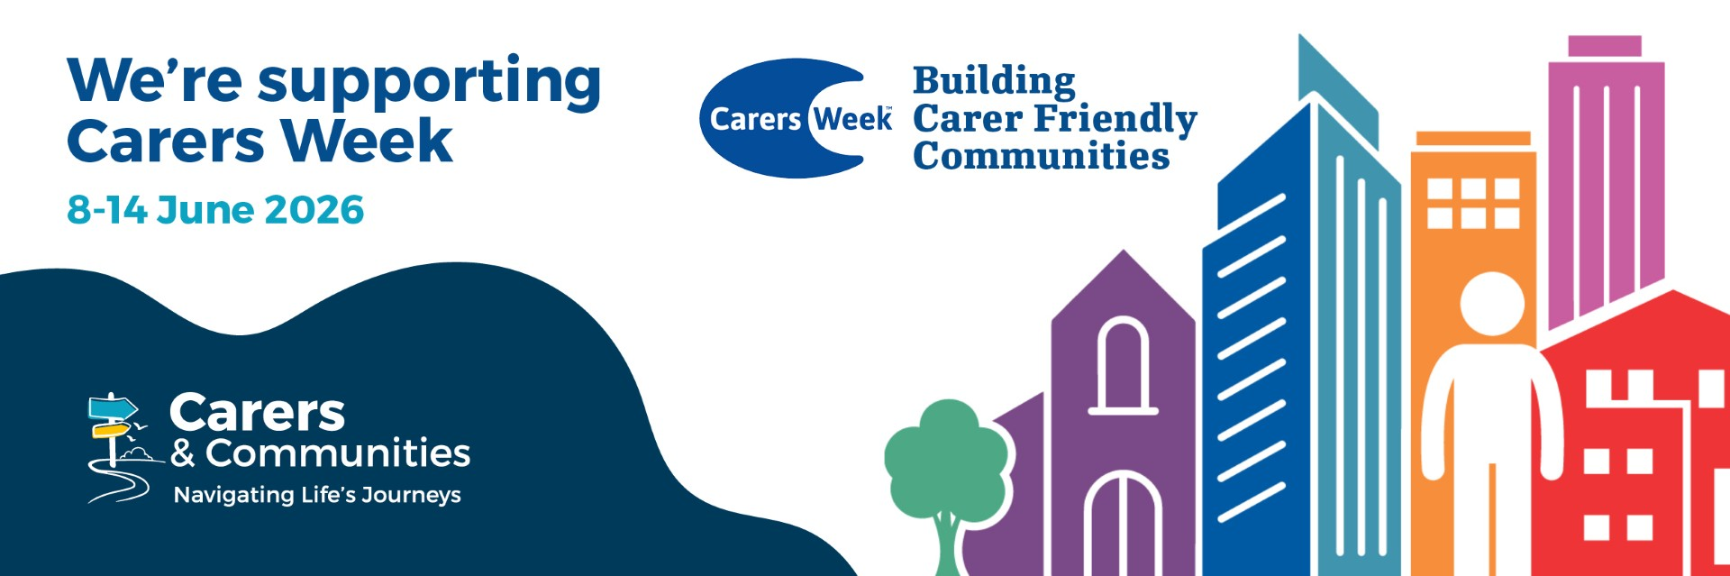
Carers Week will be held on the 8th to 14th June, and the theme is ‘Building Carer Friendly Communities.’
"Carers Week is an annual campaign to raise awareness of caring, highlight the challenges unpaid carers face and recognise the contribution they make to families and communities throughout the UK. It also helps people who don't think of themselves as having caring responsibilities to identify as carers and access much-needed support.
Our theme for Carers Week 2026 is Building Carer Friendly Communities. This will highlight the impact carer friendly communities can have in making a real and lasting difference to the lives of carers everywhere. The campaign will be brought to life by thousands of individuals and organisations taking action to ensure more communities understand, recognise, and empower carers."
Find out more at Carers UK: Carers UK
Carers & Communities
Carers & Communities support unpaid carers across Worcestershire, and are committed to raising awareness of caring, helping carers get the support they deserve and highlight the vital role our communities play.
Every day people support a loved who could not manage without them.
With 1 in 15 people becoming carers every day, Carers & Communities are available to help you get the support and guidance you need.
Caring for a loved one can be incredibly rewarding, but it's also natural to feel overwhelmed at times. Getting the right support is vital - for your physical and mental health, your finances and your overall wellbeing. It helps you continue to care while still having time and space for your own life.
If you are new to caring, or have been caring for a while, Carers & Communities can support you.
Find out more about the support and services they provide on the website: www.carersandcommunities.org.uk
You can contact us for support here: Self-Referral Form | Carers & Communities

