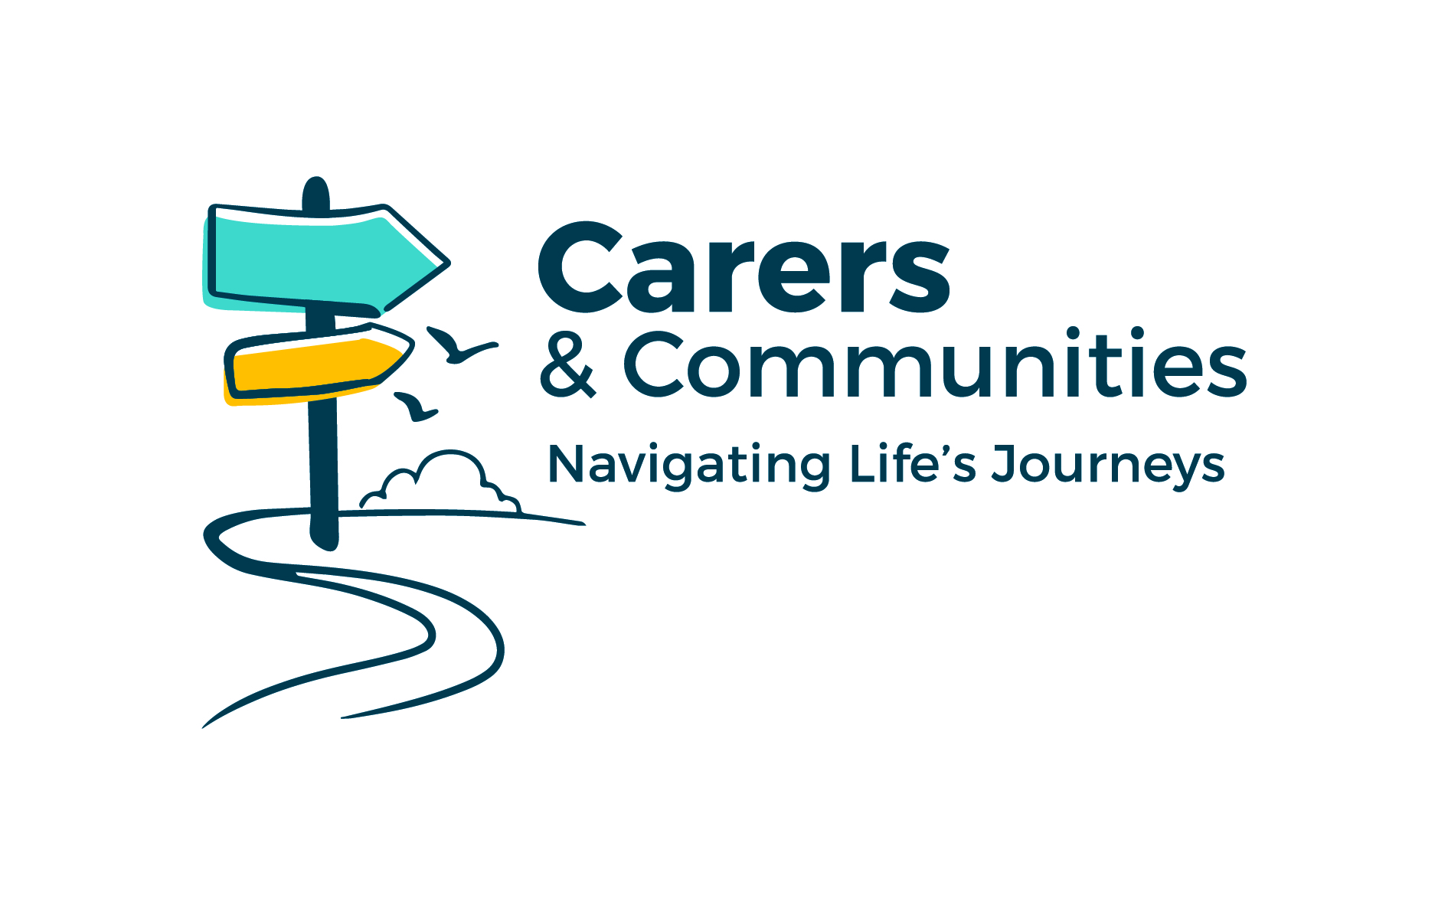
Service to clients policy
At Worcestershire Association of Carers, we understand the role of unpaid carers and the huge contribution they make to the community, and we aim to help and support you in any way we can.
We also understand that when you contact us, your situation could be stressful, and you might be frustrated. However, our staff have the right to do their jobs without being treated badly. For this reason, we won’t accept certain behaviours while helping you, for example:
- swearing or abusive language
- discrimination like racism, sexism or homophobia
- threatening violence
We’ll also ask you to respect the limits of what we can do. For example, if you:
- require the attention of specific staff when it’s not possible
- keep raising the same issue when we’ve already helped you or we can’t help more
What we’ll do if your behaviour is unacceptable
We’ll give you a chance to alter your behaviour, but if you continue, we may:
- end a conversation early
- not reply to all your communications
- only help you with certain issues
In very serious situations we might:
- stop helping you completely
- call the police
We’ll give you a chance to change your behaviour before we stop helping you - unless your behaviour threatens the safety of our staff or other people.
We’ll always try to tell you why we’ve stopped helping you.

